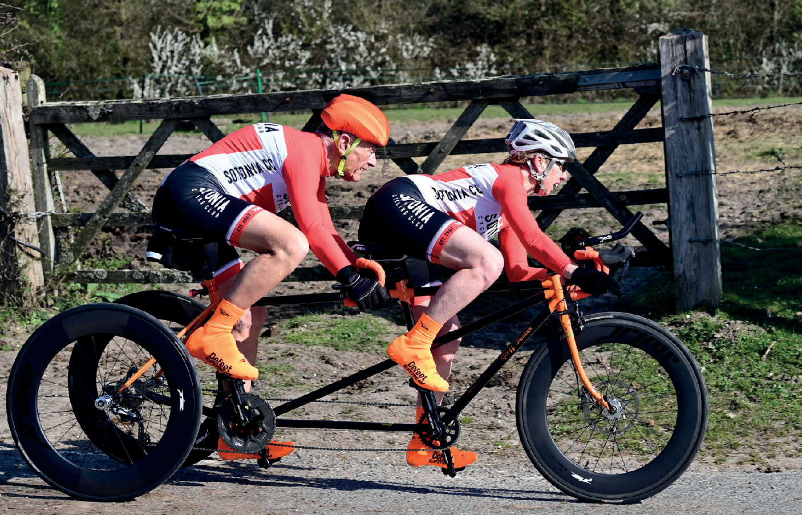

Open 10 Mile Time Trial
Sunday 8th October 2023 | Course P612/10
Promoted for and on behalf of Cycling Time Trials under their Rules and Regulations

Timekeepers: Mary Corbett, Norman Harvey, Dave Crocker
Sotonia CC

Recorder:
Organiser: Graham Harman 16 Woodman Close, Sparsholt, Winchester, Hants, SO21 2NT
07769437843

Event headquarters:
Picket Twenty Sports Ground, Sports Pavillion , Telegraph Road, Andover, SP11 6UF
HQ will open from 06.30

IN THE INTERESTS OF YOUR OWN SAFETY, Cycling Time Trials and the event promoters strongly advise you to wear a HARD-SHELL HELMET that meets an internationally accepted safety standard. It is also compulsory that WORKING FRONT & REAR LIGHTS, either flashing or constant, are fitted to the machine in a position visible to following road users and is active while the machine is in use.
There may be no pusher-offered; you will have to do a standing start on your own (one foot on the ground). Rolling starts will not be permitted.
Once you have finished your race you will be asked to return your number & sign out, back at the HQ for a tea/coffee and cake.
No warming up on the course once the event has started.
Heads up please, accidents down.
Parking
There is parking available at the Sports Pavillion.
Prizes
Male Female Road Bike Vet on STD
1st £30 £30 £30 £30
2nd £20 £20 £20
3rd £10 £10 £10

Fastest Team of 3 £30

Route to start

Follow Cycle path away from HQ then right turn onto Turnpike Road then right turn onto Picket 20 Way heading back out of the estate

Route from finish back to HQ

After finishing your race continue along A303 and turn off on next exit slip road A3093 (small climb)
Continue along this road to the 1st roundabout where you turn right passing the start area into Picket Twenty Way then turn left onto Turnpike Road and when you reach the green on your right turn left onto cycle path heading back to th HQ.

Course description

Start at drain cover at Picket Twenty road just off roundabout. Turn left and proceed to entry left to join A303(t) Andover bypass eastbound carriageway (gr385450). Travel eastbound on A303(t) for approx 6 miles where take slip road at Bullington Cross (A34 northbound/southbound). At roundabout stay in left hand lane to take 1st exist and follow road under A34 and A303(t) to turn left at next junction and rejoin A303(t) in westbound direction. Retrace westbound along A303(t) to finish at lay-by 10 mile point, approx 1 mile before slip road onto A3093 (riders not to stop at finish but continue riding and leave A303(t) at A3093 exit).

